### Online booking Application Project Report

### Author

Sakthivel K

21f3001697

21f3001697@ds.study.iitm.ac.in

I had completed B. Sc Mathematics with computer Application. Currently I am working as Application Tester in Adept chips

### Description

Application can have multiple admins and multiple users. All admins can create, edit, delete and view details of each show, venue and allocation. Also, admin can view high level summary via graphs. User can book multiple tickets for available future show in all available venues. User can view their past booking details and can rate the show after the show ends

### Technologies used

Flask🡪 create and manipulates data in db and present it to user

Flask Login 🡪 to secure only valid user can access the portal\

Flask-SqlAlchemy🡪 used ORM to get details from database

Sqlite3🡪 Used cursor to make SQL query which I felt difficult in ORM

Flask-restful🡪 CRUD on venue, show and allocation

Matplotlib🡪 to create bar graph of show and venue details

### DB Schema Design

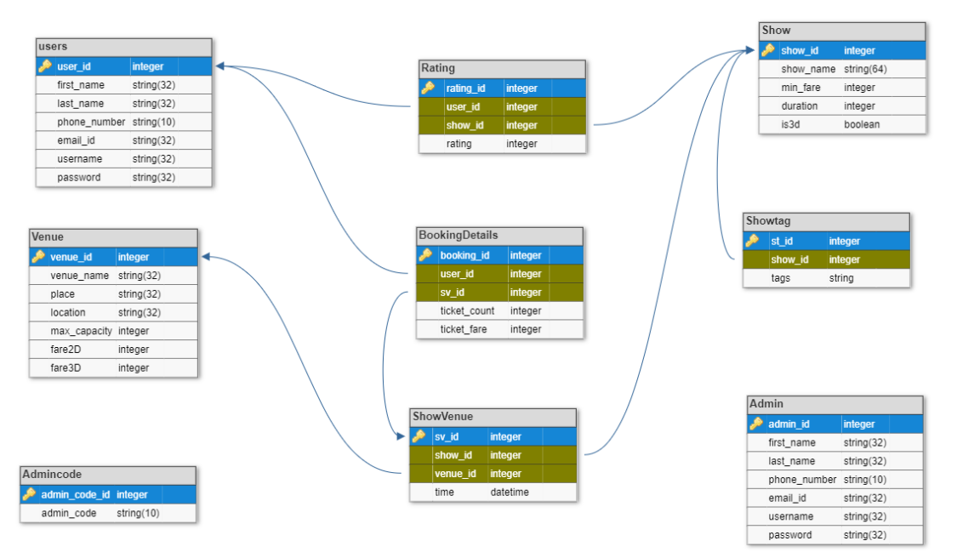

### API Design

CRUD operation on Shows

CRUD operation on Venues

CRUD operation on allocation

Read operations for filtering allocation

### Architecture and Features

├── application

├ ├── api # CRUD operations

├ └── controllers # controllers

├── instances # database file

├── models # database table model

├── static # generated matplotlib graph

├── template

├ ├── admin # admin html file

├ ├── login # user html file

├ ├── registration # registration html file

├ └── user # user html file

├── app.py # main file, app beginning

├── api.yaml # api documentation file

├── README.md # few applications rule

└── requirement.txt # required packages

#### Mandatory Features

* + Create, edit and delete venue by Admin
  + Create, edit and delete show by Admin
  + Create, edit and delete allocation by Admin
  + Booking multiple tickets per show by user
  + Registering new users and admins
  + User can rate a show after show ends
  + Reset password
  + Search by different parameter (show name, venue name, tags, rating, date)
  + All past bookings details of logged in user

#### Additional Features

* + Details of each Venue, show, allocation booking and revenue details
  + Blocking show allocation to venue if there is any time conflict
  + Filtered summary plot per venue and show
  + Block delete Venue/show in case allocation
  + Used bit of JS and bit of Regex
  + Flask login for user/normal login for admin
  + Edit Capacity in venue which should be at least equal most booking of future show
  + Admin Code (random string to register new Admin)

### Video

Please refer this link to view video